ESPERO QUE VOCÊS ESTEJAM BEM ESTOU COM SAUDADES DE VOCÊ, MAS PRECISAMOS NOS CUIDAR.

NESTE MÊS DE MAIO ESTAREMOS TRABALHANDO COM A **SEQUÊNCIA DIDÁTICA: HÁBITOS ALIMENTARES E HÁBITOS DE HIGIENE.**

**AULA 01**

PEÇA PARA UM FAMILIAR LER PARA VOCÊ A LITERATURA

**O SANDUÍCHE DA MARICOTA**

[](https://3.bp.blogspot.com/-gvJGyHiAAR4/TpzpFkUGotI/AAAAAAAACBY/2iihbtGtgRc/s1600/image0.jpg)[](https://4.bp.blogspot.com/-RAdsGps2-yU/TpzpFZLcTFI/AAAAAAAACBM/alSE28FxLEs/s1600/image1.jpg)  
  
[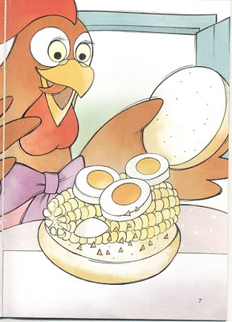](https://2.bp.blogspot.com/-HnmD-V_DHBQ/TpzpEnXxbDI/AAAAAAAACBA/1kOlSKeU9zc/s1600/image2.jpg)[](https://4.bp.blogspot.com/-558cyDoCckw/TpzpEjXf0rI/AAAAAAAACAw/vVzJyTx8dgI/s1600/image3.jpg)  
  
[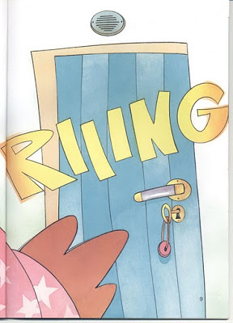](https://4.bp.blogspot.com/-fCZDX4cha0k/TpzpET4Q-HI/AAAAAAAACAo/K21jt-SgnQw/s1600/image4.jpg)[](https://2.bp.blogspot.com/-01FhWJJGLPA/Tpzo8EiTDjI/AAAAAAAACAY/0WUuSAJuq8o/s1600/image5.jpg)  
  
[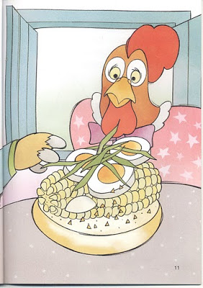](https://4.bp.blogspot.com/-ddPS5b2MFAw/Tpzo756-ZRI/AAAAAAAACAQ/idPICJozMXI/s1600/image6.jpg)[](https://3.bp.blogspot.com/-ATUAJGQTFEs/Tpzo7UkrBfI/AAAAAAAACAE/1EfMtVFADiE/s1600/image7.jpg)  
  
[](https://2.bp.blogspot.com/-z3J4vdVdCd4/Tpzo7LIbs3I/AAAAAAAAB_4/wnlRH-6A4cs/s1600/image8.jpg)[](https://3.bp.blogspot.com/-K-j-Y3ZPva4/Tpzo7P8UGXI/AAAAAAAAB_s/7xJK1LP24UE/s1600/image9.jpg)  
[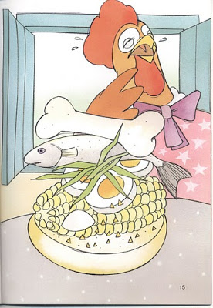](https://1.bp.blogspot.com/-L383GyULlns/Tpzox1h7CYI/AAAAAAAAB_g/XlZxzsx3ATk/s1600/image10.jpg)[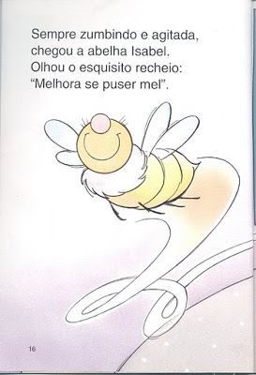](https://3.bp.blogspot.com/-QHYIzOUWgVE/TpzoxRzbSwI/AAAAAAAAB_Y/Ou4zAMjf0I8/s1600/image11.jpg)  
  
  
[](https://3.bp.blogspot.com/-BpmYgBVxybM/TpzoxEKg85I/AAAAAAAAB_I/37a95mqCvf4/s1600/image12.jpg)[](https://4.bp.blogspot.com/-2lpawKe7owc/Tpzow6r6vSI/AAAAAAAAB-4/y90HXLcnwTQ/s1600/image13.jpg)  
  
[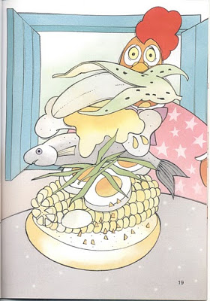](https://4.bp.blogspot.com/-uL8wsQgDa18/Tpzow3tG5EI/AAAAAAAAB-w/y0FJvmq_HrE/s1600/image14.jpg)[](https://1.bp.blogspot.com/-Xt82zeyYXUQ/TpzomCwWXDI/AAAAAAAAB-g/Xu0TFTiSOqI/s1600/image15.jpg)  
  
[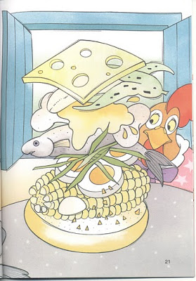](https://4.bp.blogspot.com/-n5uTviUvhGo/Tpzol4wGxXI/AAAAAAAAB-Y/lOO9Qp8maNg/s1600/image16.jpg)[](https://1.bp.blogspot.com/--EGr77fCvAQ/Tpzoliq8TOI/AAAAAAAAB-M/bJXR2sazWQo/s1600/image17.jpg)  
  
[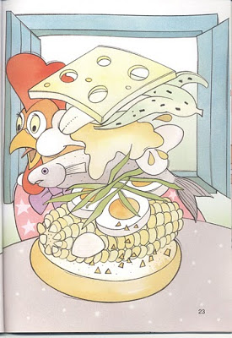](https://4.bp.blogspot.com/--Y1IIPZJ9Ks/TpzolRFcbBI/AAAAAAAAB98/k42uig2na5M/s1600/image18.jpg)[](https://2.bp.blogspot.com/-CIXqIpxZX7s/TpzolSQu3KI/AAAAAAAAB90/I376qbbi2X8/s1600/image19.jpg)  
  
[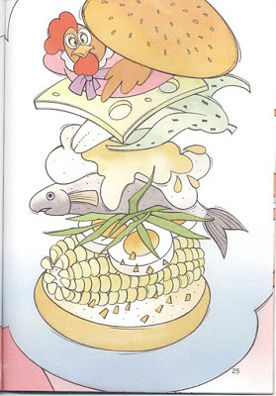](https://2.bp.blogspot.com/-DYENYLCcqSM/TpzobGGXB0I/AAAAAAAAB9s/3byxbUwSdYs/s1600/image20.jpg)[](https://4.bp.blogspot.com/-VHZD7Wrz1AM/Tpzoa5IeftI/AAAAAAAAB9c/mCQ9PG1VWNg/s1600/image21.jpg)  
  
[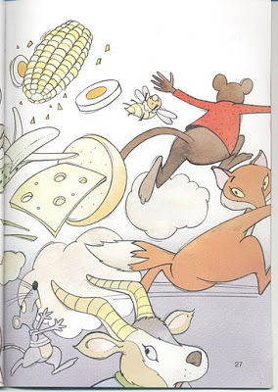](https://2.bp.blogspot.com/-1CVSGl6G5ko/TpzoaXrOVEI/AAAAAAAAB9Q/El3d1E4aiLo/s1600/image22.jpg)[](https://2.bp.blogspot.com/-SV5gVsbp3J0/TpzoaNw7JRI/AAAAAAAAB9E/yoNIpPHI6b0/s1600/image23.jpg)  
  
[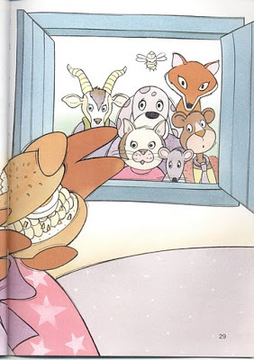](https://1.bp.blogspot.com/-sWBYLtwWD8c/TpzoaFsC8lI/AAAAAAAAB84/lIeKk-kCI1I/s1600/image24.jpg)

DE ACORDO COM A HISTÓRIA QUE VOCÊ LEU. FAÇA O TEU SANDUÍCHE SAUDÁVEL E COLOQUE DENTRO DE UMA LINDA CESTA. PODE SER FEITO COM MASSA DE MODELAR OU COM RECORTE. PODE USAR OUTROS MATERIAIS, USE SUA CRIATIVIDADE.