SEMANA DE 15 A 19 DE JUNHO
SEQUÊNCIA DIDÁTICA MÊS DE JUNHO
BONS HÁBITOS DE HIGIENE

- OBSERVE AS FIGURAS E FAÇA UMA FRASE COM CADA UMA:

02
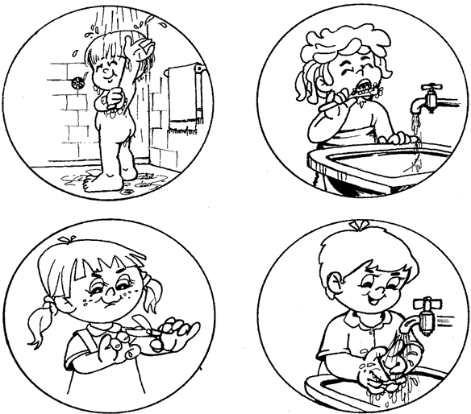
03
04
01

_____________________________________________________________________________________________________________________________________________________________________________________________________________________________________________________________________________________________
01

_____________________________________________________________________________________________________________________________________________________________________________________________________________________________________________________________________________________________
02

_____________________________________________________________________________________________________________________________________________________________________________________________________________________________________________________________________________________________
03

_____________________________________________________________________________________________________________________________________________________________________________________________________________________________________________________________________________________________
04

- RESOLVA AS SUBTRAÇÕES (COM FEIJÕES OU PALITOS DE FOSFÓRO):

8 - 7 =
12 - 11=
19 -10 =
18 - 11 =
17 - 14 =
16 - 15 =
18 - 10 =
17 - 9 =
10 - 5 =
15 - 9 +
16 - 3 =
14 - 6 =
13 - 8 =
10 - 9 =
6 - 6 =

