Primary School Alfredo Gomes
Principal: Ivania Nora
Pedagogical Advisor: Simone Carl
Secretary: Tania D’Ávila
Teacher: Giovani Cavalheiro
Grade:2nd .

ATIVIDADE 03

IDENTIFIQUE E PINTE OS ANIMAIS DE ACORDO COM AS DESCRIÇÕES:
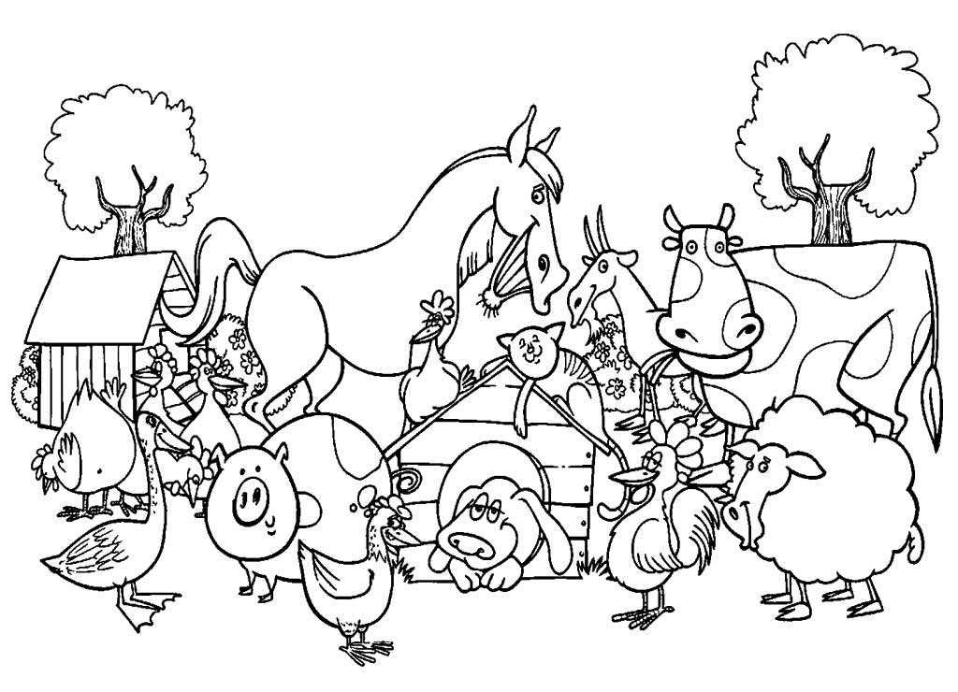

A BROWN HORSE
A YELLOW DUCK
A PINK PIG
A GRAY HEN
A BLACK AND WHITE COW
A BLACK SHEEP

