SEMANA DE 29/06 A 03/07
SEQUÊNCIA DIDÁTICA MÊS DE JULHO

LEITURA, PALAVRAS E FRASES

- LEIA E PINTE A PARLENDA:
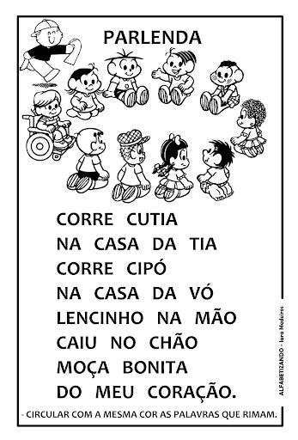

- PINTE TODAS AS PALAVRAS QUE INICIA C, E DEPOIS COPIE ABAIXO:
__________________________________________________________________________________________________________________________________________

- COM A TABELA NA MÃO FORME 5 PALAVRAS QUE INICIA COM CADA SÍLABA:
CA________________________________________________________________________________________________________________________________________
CO________________________________________________________________________________________________________________________________________
CU________________________________________________________________________________________________________________________________________
CE________________________________________________________________________________________________________________________________________
CI_________________________________________________________________________________________________________________________________________

- ESCOLHA UMA PALAVRA QUE VOCÊ ESCREVEU COM CADA SÍLABA E FORME UMA FRASE:
CA________________________________________________________________________________________________________________________________________
CO________________________________________________________________________________________________________________________________________
CU________________________________________________________________________________________________________________________________________
CE________________________________________________________________________________________________________________________________________
CI_________________________________________________________________________________________________________________________________________

