Observe a tabela:
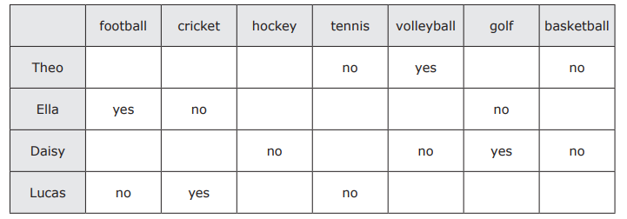

Agora, complete as frases de acordo com o exemplo:

Theo likes volleyball.
He dislikes tennis and basketball.

- Ella likes __________________________________________________.
She dislikes _______________________________________________.

- Daisy likes ________________________________________________.
She dislikes _______________________________________________.

- Lucas ____________________________________________________.
He _______________________________________________________.

