Escreva a School Subject correspondente a cada figura.
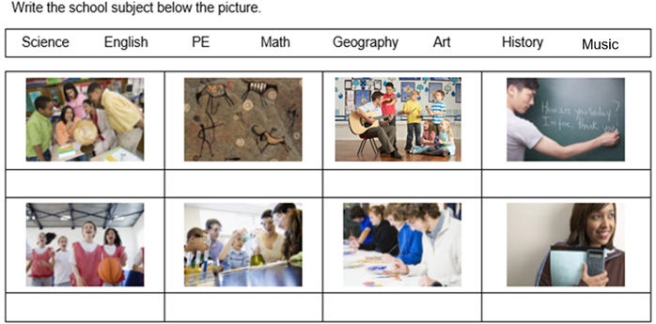
What is your favorite school subject?
My favorite school subject is …………………………………

