Observe como dizemos as horas em inglês:
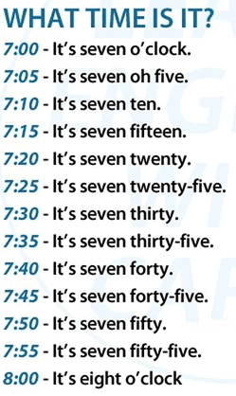

Observe os relógios e pinte-os de acordo com as orientações dadas:
TELLING THE TIME

Help Tweety color the clocks.
- Seven o’clock is red. 6. Four o’clock is orange.
- Five o’clock is yellow. 7. Two o’clock is green.
- Ten o’clock is pink. 8. Nine o’clock is brown.
- Eight o’clock is blue. 9. Six o’clock is yellow.
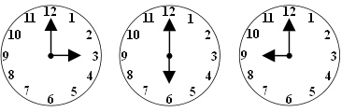
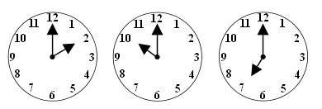
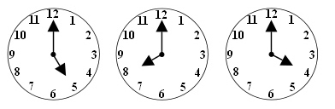
- Threeo’clockispurple.

