ESCOLA MUNICIPAL DE EDUCAÇÃO BÁSICA ALFREDO GOMES.
DIRETORA: IVÂNIA NORA.
ASSESSORA PEDAGÓGICA: SIMONE ANDRÉA CARL.
ASSESSORA TÉCNICA ADM.: TANIA N. DE ÁVILA.
PROFESSORA: ALESSANDRA - ALINE
DISCIPLINA: MATEMÁTICA
CATANDUVAS – SC
ANO 2020-TURMA

PROFESSORAS: ALESSANDRA - ALINE
SEMANA DE 02/11 A 06/11
SEQUÊNCIA DIDÁTICA MÊS DE NOVEMBRO

LEITURA, PALAVRAS E FRASES
- LEIA O TEXTO COM ATENÇÃO:
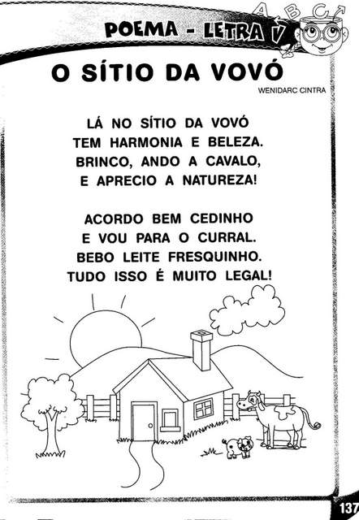
2) CIRCULE NO TEXTO AS PALAVRAS QUE POSSUEM A LETRA V:
3) FAÇA UMA FRASE COM CADA PALAVRA CIRCULADA:
_____________________________________________________________________________________________________________________________________________________________________________________________________________________________________________________________________________________________________________________________________________________________________________________________________________________

4) COMPLETE A CRUZADINHA:
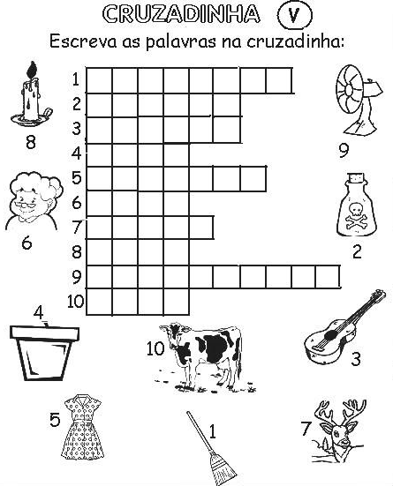
5) ESCREVA AS PALAVRAS DA CRUZADINHA E SEPARE AS SÍLABAS:
____________________________________________________________________
____________________________________________________________________
____________________________________________________________________
____________________________________________________________________
____________________________________________________________________
____________________________________________________________________
____________________________________________________________________
____________________________________________________________________
____________________________________________________________________
____________________________________________________________________
___________________________________________________________________

