ESCOLA MUNICIPAL DE EDUCAÇÃO BÁSICA ALFREDO GOMES.
DIRETORA: IVÂNIA NORA.
ASSESSORA PEDAGÓGICA: SIMONE ANDRÉA CARL.
ASSESSORA TÉCNICA ADM. TANIA N. DE ÁVILA.
PROFESSORA: DANIA CECILIA DAROLD.
CATANDUVAS – SC
ANO 2021 - TURMA 2ºANO MATUTINO

CATANDUVAS, 24 DE MAIO A 28 DE MAIO DE 2021.
NOME COMPLETO:_____________________________________________________________

*ESCREVER OS NÚMEROS DE 0 A 50. DEPOIS CÍRCULE SÓ OS PARES.
____________________________________________________________________________________________________________________________________________________________________________________________________________________________________________________________________________________________________________________________________________________________________________________________________________________________________________________________________________________
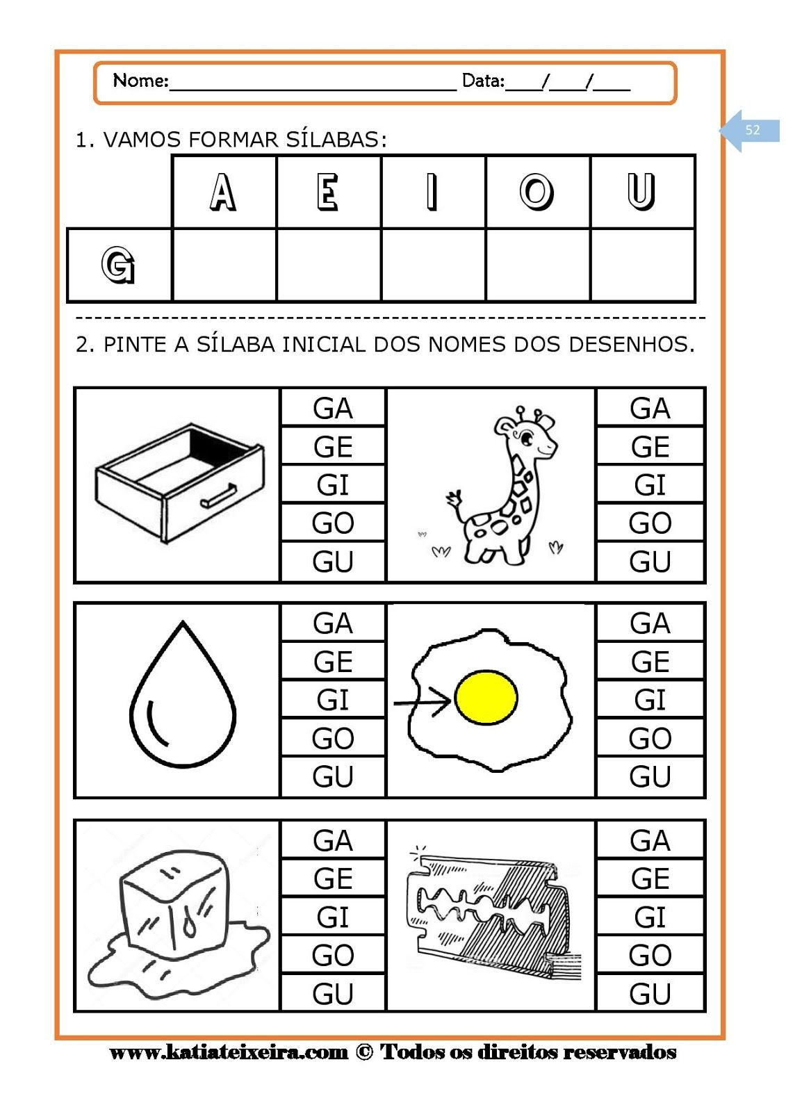

*TREINE UMA LINHA DE CADA:
GA-__________________________________________________________________________
GE-___________________________________________________________________________
GI-___________________________________________________________________________
GO-__________________________________________________________________________
GU-___________________________________________________________________________
GÃO._________________________________________________________________________

*RECORTE DE LIVROS E REVISTAS 20 PALAVRAS COM A LETRA G. COLE NO RETÂNGULO. LEIA.

*ESCREVA POR EXTENSO.
20-VINTE
21- VINTE E UM
22_________________________ 36___________________________________
23__________________________ 37___________________________________
24____________________________ 38____________________________________
25____________________________ 39___________________________________
26____________________________ 40__________________________________
27____________________________ 41__________________________________
28____________________________ 42__________________________________
29___________________________ 43__________________________________
30___________________________ 44__________________________________
31___________________________ 45__________________________________
32___________________________ 46 __________________________________
33____________________________ 47__________________________________
34_____________________________ 48__________________________________
35_____________________________ 50___________________________________

