|  |  |  |
| --- | --- | --- |
|  | |  | | --- | | **ESCOLA MUNICIPAL DE EDUCAÇÃO BÁSICA ALFREDO GOMES.**  CATANDUVAS, MAIO DE 2021.  DIRETORA: IVANIA AP. NORA  ASSESSORA TÉCNICA PEDAGÓGICA: SIMONE ANDRÉA CARL  ASSESSORA TÉCNICA ADMINISTRATIVA: TANIA NUNES DE ÁVILA  Professora: **LORENI S. P. MECABÔ** | |

**ALUNO(A):__________________________________**

**AULA PROSEDI**

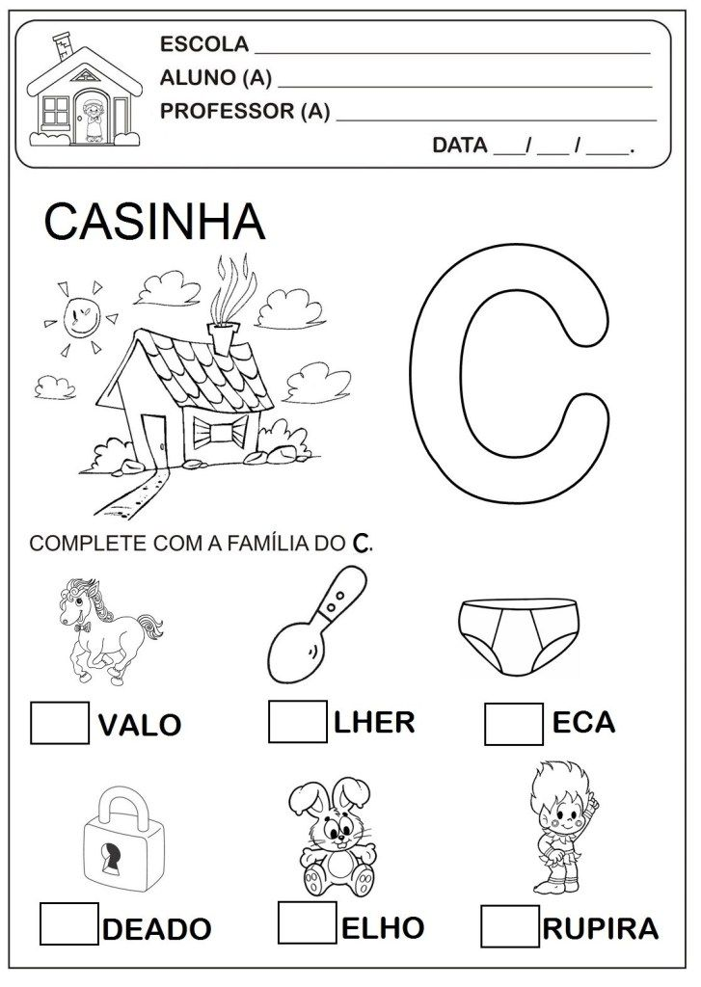

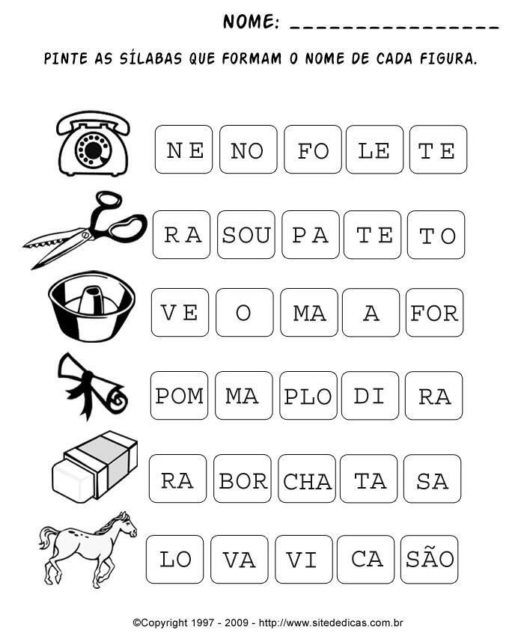

**DEPOIS DE PINTAR AS SÍLABAS COPIE-AS:** ____________________________________________________________________________________________________________________________________________________________________