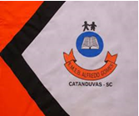 | ESCOLA MUNICIPAL DE EDUCAÇÃO BÁSICA ALFREDO GOMES.  DIRETORA: IVÂNIA NORA.  ASSESSORA PEDAGÓGICA: SIMONE ANDRÉA CARL.  ASSESSORA TÉCNICA ADM. TANIA N. DE ÁVILA.  PROFESSORA: DANIA CECILIA DAROLD.  CATANDUVAS – SC  ANO 2021 - TURMA 2ºANO MATUTINO

CATANDUVAS, 21 DE JUNHO A 25 DE JUNHO DE 2021.
NOME COMPLETO:_____________________________________________________________

*ASSISTIR AO VÍDEO: “APRENDA A LETRA H COM O NOSSO AMIGO HEITOR”:
https://youtu.be/cRw6sih8twQ
*ESCREVA 15 PALAVRAS COM A LETRA H E DEPOPIS TREINE A LEITURA: _______________________________________________________________________________________ _______________________________________________________________________________________ _______________________________________________________________________________________ _______________________________________________________________________________________ *ESCOLHA 6 PALAVRAS DA ATIVIDADE ANTERIOR E FORME FRASES:
________________________________________________________________________________________________________________________________________________________________________________________________________________________________________________________________________________________________________________________________________________________________________________________________________________________________________________________________________________________________________________________________________________________________________________________________________________________________________________________________________________________________________________________________________________________________________________________
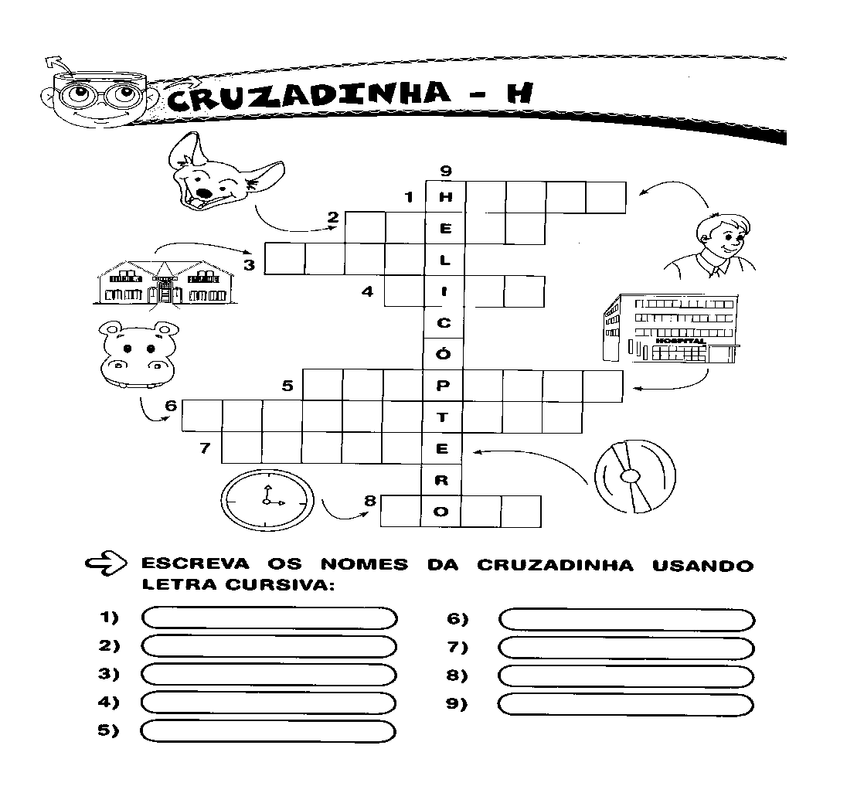

*RESOLVA.
