ESCOLA MUNICIPAL DE EDUCAÇÃO BÁSICA ALFREDO GOMES.
DIRETORA: IVÂNIA NORA.
ASSESSORA PEDAGÓGICA: SIMONE ANDRÉA CARL.
ASSESSORA TÉCNICA ADM. TANIA N. DE ÁVILA.
PROFESSORA: DANIA CECILIA DAROLD.
CATANDUVAS – SC
ANO 2021 - TURMA 2ºANO MATUTINO

CATANDUVAS, 05 DE JULHO A 09 DE JULHO DE 2021.
NOME COMPLETO:_____________________________________________________________

*ESCREVA POR EXTENSO. 25___________________________
1-________________ 11-___________________ 21___________________________
3-________________ 13-___________________ 23___________________________
5-________________ 15___________________ 35___________________________
7-________________ 17___________________ 39___________________________
9-_________________ 19___________________ 47___________________________
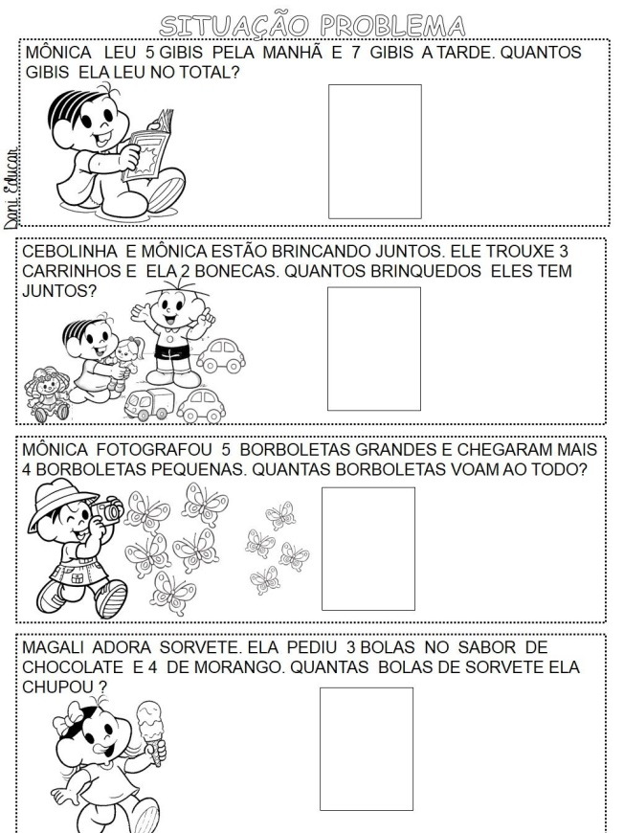
*RESOLVA OS PROBLEMAS: COLOCAR A OPERAÇÃO DENTRO DO QUADRADO. E A RESPOSTA DO LADO.

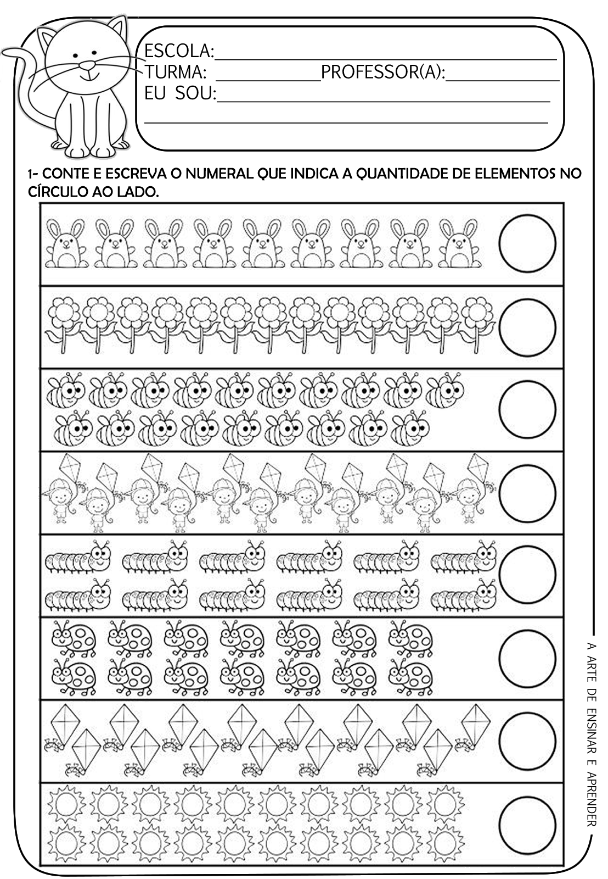
*CONTE E REGISTRE A QUANTIDADE DENTRO DO CÍRCULO. DEPOIS PINTE

*JUNTE SÓ AS SÍLABAS DO RETÂNGULO E FORME 25 PALAVRAS:
BA- BE- BO- CA- CE- CO- CI- DA- DE- DO- FA- FO- FI- GA-GO- GE- HO- HA- JA- JE –JI – JO –JU - A LA- LE- LI- LO.
____________________________________________________________________________________________________________________________________________________________________________________________________________________________________________________________________________________________________________________________________________________________________________________________________________________________________________________________________________________________________________________________________________________________________________________________________________________________________________________________________________________________________________________________________________________________________________________________________________

*SEPARE EM SÍLABAS:
JANELA-__________________________ LUVA_____________________________
GALINHA__________________________ FADA______________________________
BIGODE___________________________ FIGO______________________________
BONECA__________________________ LAGO_____________________________
HIPOPÓTAMO_______________________________ HOJE_________________________

*FORME UMA FRASE COM CADA PALAVRA: LARANJA, JACARÉ, JOGO, PANELA, BONECA, HIPOPÓTAMO, GALINHA, LIMONADA, LIQUIDIFICADOR, LOJA, ELEFANTE.
____________________________________________________________________________________________________________________________________________________________________________________________________________________________________________________________________________________________________________________________________________________________________________________________________________________________________________________________________________________________________________________________________________________________________________________________________________________________________________________________________________________________________________________________________________________________________________________________________________________________________________________________________________________________________________________________________________________________________________________________________________________________________________________________________________________________________________________________________________________________________________________________________________________________________________________________________________________________________________________________________________________________________________________________________________________________________________________________

*RESOLVA A CRUAZADINHA.
